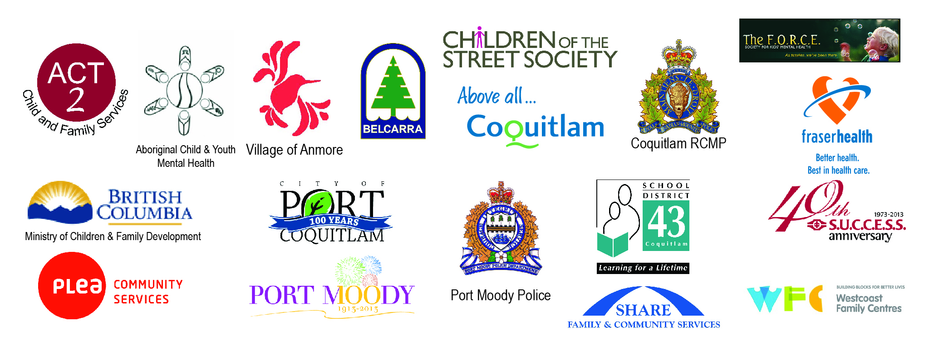

Safe Schools and Communities for our Students
October Newsletter
October 23, 2014

To all Parents and Guardians of Children and Youth in the Tri-Cities,

With the goal to strengthen our collective efforts to keep our children and youth safe and unharmed in our communities and neighborhoods, we are committed to another year of bringing our School District 43 families information through a common newsletter. With the support of multiple communities and agencies, and with the three cities and two villages, we will be pooling our resources, knowledge, and data in a collective effort to take care of our future generations. We share the responsibility for the safety of our children with parents, guardians and the greater community. Together we are stronger.

Our focus in this newsletter is to redefine our purpose with this work, to keep parents and guardians up-to-date with information, and supports in place for our children, youth and families, and to provide helpful ideas, based on solid research, to arm our children with the strength and resiliency to confront and succeed in life’s challenges.

The focus of this first letter is to serve as a reminder to all of our families that there are simple things we can do as adults that positively influence our kids’ ability to cope with life’s challenges. We say these are simple, because we already know them to be good practice, however they sometimes get lost in the busy day-to-day challenges.

FACT: 18-25% of our youth report mental health issues by the age of 19, which is significant; and there are family practices that serve as protective factors beginning at a very young age.

FACT: Anything parents and caregivers can do to INCREASE PROTECTIVE SUPPORTS for our children will make a difference. Research suggests the following ideas are extremely impactful.

- Have meals together as a family often as possible.
- Ensure that your child(ren) is getting enough rest. From kindergarten to Grade 12, children need at least 9 hours per night to cope with all of the stressors and to be prepared for the day.
- Be aware of the influences of online activity and social media on brain activity, and plan a “turn off” time well prior to lights out, or limit the use of these devices to reading online before bed. Watch out for kids accessing online media after hours, alone, in their bedroom. This becomes increasingly challenging as our kids use their phones for alarm clocks and other reminders.
- Help your child(ren) build positive social circles with friends. For younger children, help arrange play dates. For older ones, keep your home open to socializing and welcome youth, with guidelines.
- Encourage caring relationships with other safe adult family members and close friends.

We have speakers lined up for this year to support SD43 parents, caregivers and educators in our commitment to be the best for our kids. Please expect the next newsletter to arrive in December 2014.

Online Resources: www.connectsafely.org/facebook-for-parents/
www.commonsensemedia.org/advice-for-parents

Julie Pearce, Co-Chair
Safe Schools Task Force
School District 43 (Coquitlam)
Cindi Seddon, Co-Chair
Safe Schools Task Force
School District 43 (Coquitlam)

